**Department of Computer Science and Information Technology**

**WIRELESS AND MOBILE COMMUNICATION: CSIWZG520**

**Laboratory Work Sheet -I**

1. **Lab Exercise:**

**Problem Statement:** To determine the free space loss and analyse the power received at the receiver with respect to the distance for different path loss exponents using MATLAB program

**Steps to be followed:**

**In- Lab task: Formulate and explain about the following topics**

• Free space path loss formula

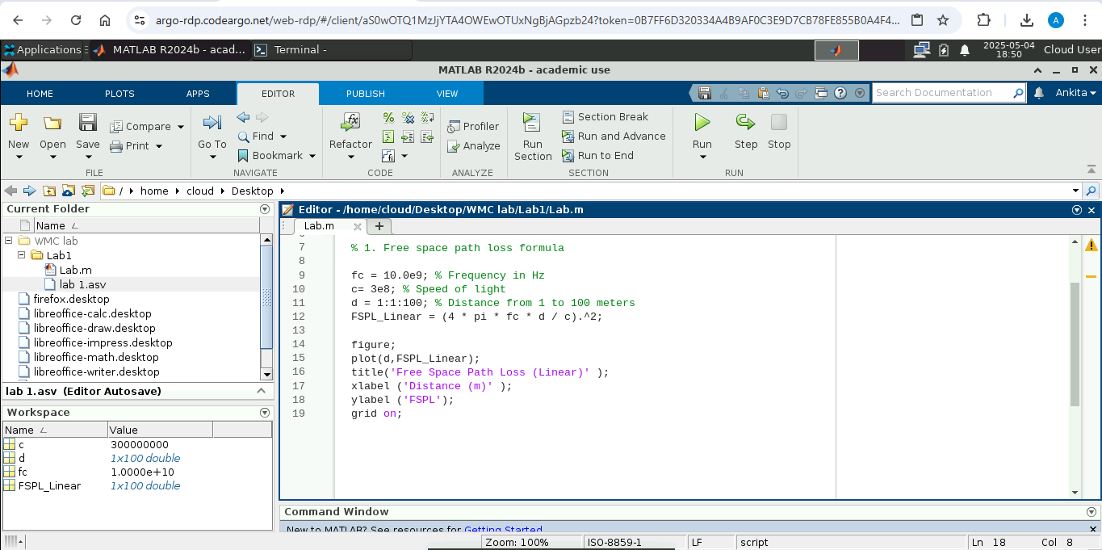

• Free space path loss equation (Decibel)

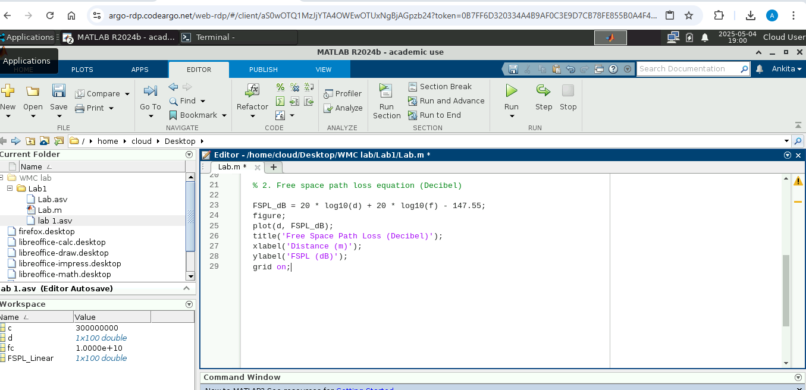

• Effect of antenna gain on path loss equation

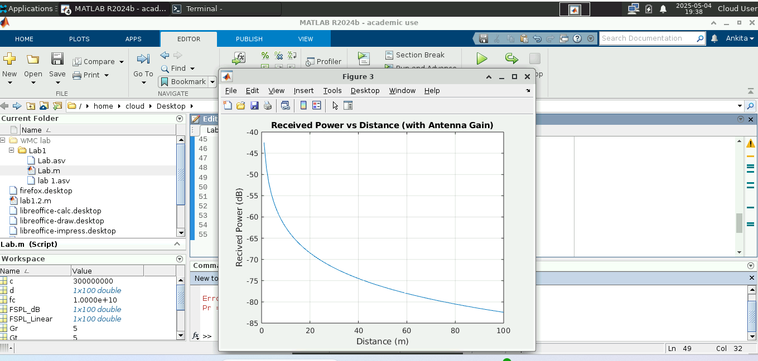

• Power Received

**Observation:**

**Results:**

**Post - Lab task:**

1. Comment on the received power with respect to path loss of signal

The received power decreases as path loss increases. Path loss is directly proportional to the square of the distance and inversely proportional to the square of the wavelength. Higher frequencies result in greater path loss, reducing the received power.

1. Plot the graph between received power (in Watts) and distance.

******